
1191 Huntington Drive, Suite 188
Duarte, CA 91010, USA
Phone: (626) 930-0160
Fax: (626) 628-3885
Psychological Associates, Inc.
SBL Number | 01
Title | Can You Work With This Prospect?
Section | Storyboard
Document Type | Script/ Structure
Location | n/a
Date | 04-21-05
Instruction | “Ctrl + Click” to follow links  - To place comments for each block → Type in: PA Comments: “text”  - Upload with updated date → http://ela.vftraining.com/psychological-associates-q4/files/index?folder_id=36219&n_past_days=99999

Mentor/ Narrator: Screen 17, 18, 19, 22, 23, 25

SCREEN NO. 1
Frame 1A
Text superimposition on screen  Can You Work With This Prospect? | Audio  SFX:  Mellow instrumental music – as if office pipe-in music.
Frame 1B
Below first Text Super, fade in:  Before you call Tom Jenkins back, remember to size up his behavior, think of how you’ll respond to it in a way that will benefit him, and have in mind a reasonable commitment you want from him as the next step. | Audio  SFX:  Mellow instrumental music – as if office pipe-in music.
Frame 2
On screen:  Static Illustration:  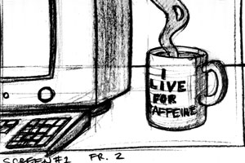  Medium shot of mug near the computer brimming with hot coffee. Mug should have “I live for caffeine” design or something to that effect.  Text Superimposition at the bottom part of the screen:  Will you be able to shake off the lack of sleep and a stale doughnut to organize your approach and use the people skills that result in sales success? Good luck! | Audio  SFX:  Mellow instrumental music – as if office pipe-in music. | Screen 2  PA COMMENT: Good!
COMMENTS:

Back to top

SCREEN NO. 2
Frame 1
Description:

On Screen:  Static Illustration:  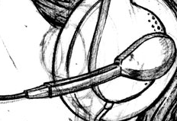  Frame 1 – Extreme close up of a headset.  Text Superimposition at the bottom part of the screen:  You listen to a voice mail . . . | Audio file of voice mail  Tom:  “Hello? This is Tom Jenkins at Welco Plastics. I’m the plant manager here at our assembly facility on Third Street. Anyway, my boss asked me to call a security firm to find out about installing some kind of security camera system. If you could give me a call at 555-4978, I’d appreciate it.” | On client’s comments:  We will focus on the headset so as to avoid any indication of the gender of the seller.  PA COMMENT: That works
Frame 2
On Screen:  Static Illustration:  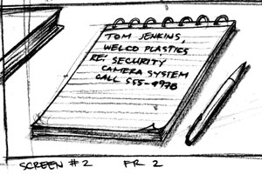  Medium shot of a notepad with “Tom Jenkins Welco Plastics. Re: Security camera system. Call 555-4978” scribbled on it.  Text Superimposition at the bottom part of the screen:  You call back Tom and introduce yourself. Then, you say . . . | SFX 1  Phone ringing (as if heard from a receiver)  SFX 2  Line clicking, call is answered. | PA COMMENT: approved
CHOICES FOR SCREEN 2
On Screen:
Static Illustration:
Medium shot of a notepad with “Tom Jenkins Welco Plastics. Re: Security camera system. Call 555-4978” scribbled on it.

SELECTED SCRIPT |  | On click, go to Screen #:
A. Rather than discuss your needs now, if I could see your facility, I can show you what we offer. Now, I can meet after this Thursday if that will work for you . . . |  | Screen 3
B. You said in your message you need a security camera system. We have all kinds. What type were you thinking about? |  | Screen 4
C. May I ask what prompted your boss to investigate security cameras at this time? |  | Screen 5
D. I’m glad you called; we offer the widest variety of security systems. You may need more than cameras, since that’s fairly basic. |  | Screen 6
COMMENTS: This applies to all seller illustrations: We have to hide gender. I know this is difficult, but we can’t show male hands, haircut, clothes, etc. Can you show a headset in screen 1 without knowing it is a male head?

Back to top

SCREEN NO. 3
Frame 1
Description:
Now the scene takes us to the office of Tom Jenkins.
On Screen:  Static Illustration:  (should cross out Winston Security Systems – Welco should not be in the list)  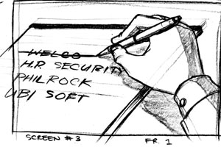  Winston Security Systems  Close up shot from high angle of Tom’s hand as if he had just crossed out the name of the security company written on his planner. | Audio file:  Tom:  “Hmm. My boss wants me to get some information NOW. I can’t wait till then. Thanks anyway.”  SFX 1  Sound of pen making a hasty line (as if crossing out something)  SFX 2  Phone disconnect and dial tone | NOTE:  Should cross out the name of the Security company – not WELCO –  Winston Security Systems
CHOICES FOR SCREEN 3
SELECTED SCRIPT |  | On click, go to screen #:
Well. That didn’t go well. Maybe I was thinking about what would work well for me before finding out what he needed. I’ll try again. |  | Screen 1
COMMENTS:

Back to top

SCREEN NO. 4
Frame 1
On Screen:  Static Illustration:  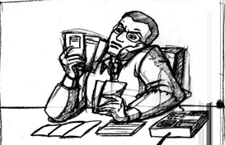  4-20-05  Medium shot of Tom behind his desk and on the phone, his expression slightly confused/ perplexed. The phone pressed on his ear and shoulder to free up his hands. He’s holding up several securities company brochures.  More reluctant and skeptical | Audio:  Tom:  “I have no idea. My boss asked me to call several security companies.” | PA COMMENT: approved
CHOICES FOR SCREEN 4
SELECTED SCRIPT |  | On click, go to screen #:
A. May I ask what prompted him to look into security cameras at this time? |  | Screen 5
B. I see. I think rather than discuss your needs now, I could show you what we offer. I can meet after this Thursday if that works . . . |  | Screen 3
C. I see. Would it be possible, then, to talk with your boss at this time? |  | Screen 7
D. Well, you called the right one. We can install the latest in security systems. Security cameras alone may not be what you need. |  | Screen 6
COMMENTS: Frame 1 illustration: Be sure Tom is Q2 reluctant, skeptical. He doesn’t want to be doing this. His boss made him. Later, we will show increasing interest as learner makes correct choices.

Back to top

SCREEN NO. 5
Frame 1A
On Screen:  Static Illustration  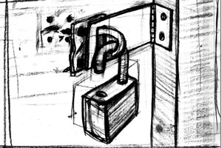  Close up shot of a door with padlock tampered. | Audio File:  Tom:  “Well . . . he feels like we need to do more about the break-ins we’ve had recently. | PA COMMENT: approved
Frame 1B
On Screen:  Static Illustration  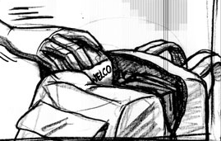  04-20-05  Medium shot from a high angle of hands sneaking company merchandise inside a backpack or bag. | Audio File:  Tom:  Oh, yes, he also mentioned that internal theft is becoming a bigger problem all the time. Do you really need to get into that right now? Like I said, we already know that we want security cameras.” | PA COMMENT: nice  PA COMMENT: approved
CHOICES FOR SCREEN 5
On Screen:
Static Illustration:

Medium shot from a high angle of hands sneaking company merchandise inside a backpack or bag.

SELECTED SCRIPT |  | On click, go to Screen #:
A. We don’t have to, no. We have a wide range of camera systems, but I would need to come by and survey your layout to recommend anything. |  | Screen 3
B. You feel security cameras are what you need. If I may ask, what kind of security or surveillance do you have now? |  | Screen 8
C. Well, to be effective, cameras are just part of a total security system. May I tell you about the systems we have? |  | Screen 13
COMMENTS:

Back to top

SCREEN NO. 6
Frame 1A
On Screen:  Static Illustration  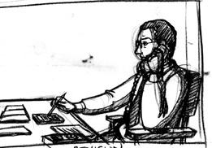  04-20-05  Medium shot taken from the side view of Tom sitting behind his table, his free hand tinkering with a calculator.  Be sure Tom looks skeptical. He is suspicious of the motives of salespeople.  Wouldn’t he have a desk instead of a table. He’s the plant manager. A desk, but if we see any of his office, it is practical looking and not high cost items. Nothing decorative about the desk or office. | Audio File:  Tom:  “I don’t know . . . that’s starting to sound like there’ll be a lot of disruption . . . and expensive too. I don’t think we want to raid Fort Knox just to upgrade our security.” | PA COMMENT: approved  PA COMMENT: approved
CHOICES FOR SCREEN NO. 6
On Screen:
Static Illustration:

Medium shot taken from the side view of Tom sitting behind his table, his free hand tinkering with a calculator.

SELECTED SCRIPT |  | On click, go to screen #:
A. Trust me, I’m just trying to understand better what you need. How much square footage do you have? How many entrances and exits? |  | Screen 9
B. I didn’t mean to jump the gun. Let me ask, what prompted your boss to look into security cameras at this time? |  | Screen 5
C. That’s a good point. Maybe the place to start is to ask you what kind of budget you have in mind for security.” |  | Screen 10
D. Perhaps, your boss would have a better idea. Is he available to talk about it? |  | Screen 7
COMMENTS: Fram 1A Be sure Tom looks skeptical. He is suspicious of the motives of salespeople.
Wouldn’t he have a desk instead of a table. He’s the plant manager. A desk, but if we see any of his office, it is practical looking and not high cost items. Nothing decorative about the desk or office.

Back to top

SCREEN NO. 7
Frame 1
Description:
We can re-use the illustration from screen no.3

On Screen:  Static Illustration  (should cross out Winston Security Systems – Welco should not be in the list)  Winston Security Systems  Close up shot from high angle of Tom’s hand as if he had just crossed out the name of the security company written on his planner. | Audio File:  “Well, he’s not available. But I’ll give him your phone number if he wants to give you a call you back. Thanks.”  Tom:  “Well, he’s not available. But I’ll give him your phone number if he wants to call you back. Thanks.”  SFX 1  disconnect line  SFX 2  Sound of dial tone | Note:  Grammatical error on the Voice Over script, I underlined the said dialogue.  Option Script:  “Well, he’s not available. But I’ll give him your phone number if he wants to call you back. Thanks.”  PA COMMENT: approved
CHOICES FOR SCREEN NO. 7
On Screen:
Static Illustration:

Close up shot from high angle of Tom’s hand as if he had just crossed out the name of the security company written on his planner.

ORIGINAL SCRIPT |  | On click, go to Screen #:
Wow. Wrong move. I thought since his boss was calling the shots . . . but, then, he did say his boss gave Tom the job of scouting companies. I won’t make that mistake again. |  | Screen 1
COMMENTS: Good idea of Tom crossing off the seller’s company name!

Back to top

SCREEN NO. 8
Frame 1
Description:

On Screen:  Static Illustration  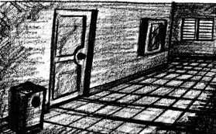  Full shot of a dark and empty hall.  Text Superimposition at the bottom part of the screen:  You ask Tom what kind of security surveillance his company does have in place. | Audio File 1:  Tom:  “Well . . . you know, I guess it’s not much. We don’t have any cameras at all.”  Mentor/ Narrator:  You ask Tom what kind of security surveillance his company does have in place. | PA COMMENT: approved
Frame 1 B
On Screen:  Static Illustration  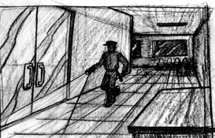  04-20-05  Full shot of silhouette of a guard on duty sitting by the door. | Audio File 2:  Tom:  “We have a 24-hour guard, but it’s just one person at any one time for this whole facility. Uh, there are bars on all the windows, if that counts.” | PA COMMENT: Now that I see it, I don’t care for a closed sign, like it’s a retail shop. This is a large facility. If we show a single guard walking along the side of a building on the outside or along a dark corridor, that would work.  PA COMMENT: approved If cost becomes a factor in doing this, feel free to use close up and suggestion. You could have a flashlight beam on a door handle and the sound of echoed footsteps
CHOICES FOR SCREEN NO. 8
On Screen:
Static Illustration:

Full shot of silhouette of a guard on duty sitting by the door.

SELECTED SCRIPT |  | On click, go to Screen #:
A. What’s nice about today’s security systems is that much of the initial cost can be offset by eliminating patrolling guards. I know cost is important to you. |  | Screen 12
B. It could. Tell me, if you will Mr. Jenkins, about access to your building. |  | Screen 17
C. To be honest up front, I think we’d have to start from scratch. You may need a new system. Fortunately, we offer the entire package. |  | Screen 6
COMMENTS:

Back to top

SCREEN NO. 9
Frame 1

On Screen:  Static Illustration  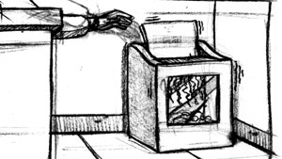  Medium Shot of folder or brochure of your company being shredded in a machine. - Winston Security Systems | Audio File:  Tom:  “Geez, I don’t have that information right now. I’m just trying to find out some things about security cameras, and you’re already measuring my building. Uh, I think I may need to talk to someone else. Thanks.”  SFX 1  Sound of shredding machine. | On Client’s Comment:  Dialogue in bold indicates that the level of tension on Tom’s voice is higher than normal.  PA COMMENT: approved  Winston Security Systems
CHOICES FOR SCREEN NO. 9
On Screen:
Static Illustration:

Medium Shot of folder or brochure of your company being shredded in a machine.

SELECTED SCRIPT |  | On click, go to Screen #:
Well, there’s my answer. He felt pinned down being asked such specific, closed end questions at this point. Time to fix this. |  | Screen 1
COMMENTS: I notice some of Tom’s dialogue is in bold and some isn’t. I assume that is for a purpose.

Back to top

SCREEN NO. 10
Frame 1A  Description:  Cut-to-cut of photos illustrate Tom’s building up suspicions and the tension between the two. | On Client’s comments:  This is just an explanation of the rationale behind the series of the photos to be shown.
On Screen:  Static Illustration  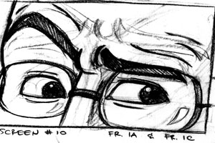  Extreme Close Up of Tom’s eyes and raised eyebrows. | Audio File:  Tom:  I have no idea about budget at this time.
Frame 1B
On Screen:  Static Illustration  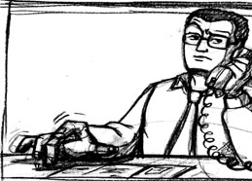  Close up shot of Tom impatiently tapping his fingers on top of his table. | Audio File:  Tom:  I’m calling for my boss to get some information. It still sounds like you’re trying to figure out how much this job will be worth… | PA COMMENT: approved
Frame 1C
On Screen:  Static Illustration  Extreme Close Up of Tom’s eyes and raised eyebrows. | Audio File:  Tom:  ...not what we can afford.
CHOICES FOR SCREEN NO. 10
On Screen:
Static Illustration

Extreme Close Up of Tom’s eyes and raised eyebrows.

ORIGINAL SCRIPT |  | On click, go to Screen #:
A. I didn’t mean to jump the gun. Let me ask, what prompted your boss to look into security cameras at this time? |  | Screen 5
B. I thought you would appreciate knowing up front that security often entails extensive changes. I wanted to be realistic about the cost. |  | Screen 11
COMMENTS:

Back to top

SCREEN NO. 11
Frame 1A
Description:

On Screen:  Static Illustration  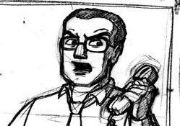  04-20-05  Medium shot of Tom looking shocked and upset. His mouth open and his forehead furrowed. | Audio File:  Tom:  Extensive changes? You’re really jumping the gun here. | PA COMMENT: approved
Frame 1B
On Screen:  Static Illustration  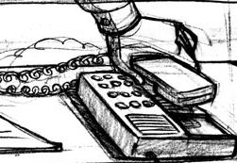  Close up shot of Tom’s hand as he put the phone down. | Audio File:  Tom:  Uh, look, I’ll get back to you if we decide to use your services.  SFX1:  disconnect  SFX2:  dial tone | PA COMMENT: approved
CHOICES FOR SCREEN NO. 11
On Screen:
Static Illustration:

Close up shot of Tom’s hand as he put the phone down.

ORIGINAL SCRIPT |  | On click, go to Screen #:
Hmm . . . Tom isn’t interested in discussing his budget. But that’s a good qualifying question. Shouldn’t I try to find out how much he has to spend?  I guess I should remember the Q2 needs of this particular prospect. |  | Screen 1
COMMENTS:
COPY CHANGE ABOVE

Back to top

SCREEN NO. 12
Frame 1A
On Screen:  Static Illustration  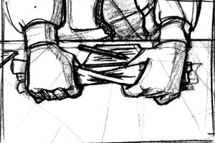  04-20-05  Close up shot of Tom’s hands twisting up the brochure – insinuating that it’s already trash. | Audio File:  Tom:  “You’re right about that. (pause) But my boss would have a fit if I was to suggest replacing our guards. He believes in the human presence on the scene. | On Screen Option:  Close up shot of Tom’s hands twisting up the brochure – insinuating that it’s already trash.  PA COMMENT: approved
Frame 1B  Description:  From Tom’s office, we move the focus to the seller. | On Client’s Comments:  This is just an explanation that the venue will return to the seller.
USE A TRANSITION LIKE A SCREEN WIPE TO HIGHLIGHT CHANGE OF LOCATION.  On Screen:  Static Illustration  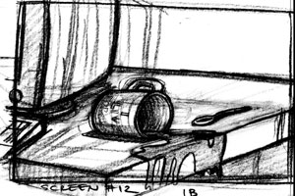  04-20-05  Medium shot of the seller’s coffee mug as he/she accidentally spilled its content because of his/her surprise. | Audio File:  Tom:  ...I-I don’t think we’re going to make that kind of change. Maybe another time. Thanks.  SFX:  Seller as if mixing his/her coffee – sound of spoon hitting the sides of the mug. | PA COMMENT: Would a SFX work here of the cup with a spoon in it jangling and we see the cup and spoon. Something like that?  PA COMMENT: approved
CHOICES FOR SCREEN NO. 12
On Screen:
Static Illustration:

Medium shot of the seller’s coffee mug as he/she accidentally spilled its content because of his/her surprise.

ORIGINAL SCRIPT |  | On click, go to Screen #:
3-30-05 Changes  Arggh! I thought I was offering a solid product advantage, but I need to keep in mind this prospect’s reluctance to change. I made an assumption I shouldn’t have this early on. Sighh . . . time to try again. |  | Screen 1
COMMENTS:

Back to top

SCREEN NO. 13
Frame 1
On Screen:  Static Illustration  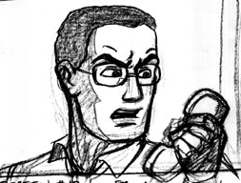  04-20-05  Medium shot of Tom looking shocked and upset. His mouth open and his forehead furrowed. | Audio File:  Tom:  I don’t know . . . I’m asking about security cameras, and it already sounds like you’re trying to pad out your order. | NOTE:  We can re-use shot from Screen 11 Frame 1A  PA COMMENT: Now that I see it, less shock and more suspicion, feeling the learner is trying to fast-talk him into something. He can still look at the phone, but more distrustful disbelief.  PA COMMENT: approved Good!
CHOICES FOR SCREEN NO. 13
On Screen:
Static Illustration:

Medium shot of Tom looking shocked and upset. His mouth open and his forehead furrowed.

ORIGINAL SCRIPT |  | On click, go to Screen #:
A. Well, you called me. Frankly, Mr. Jenkins, I can’t tell you much until I can visit to see your facility. Make sense? |  | Screen 3
B. I didn’t mean to sound that way. I was just characterizing what security means today. Okay, you tell me, what specifically would you like to know? |  | Screen 14
C. Well, I didn’t mean to sound that way. May I ask a few more questions that will enable me to help you? |  | Screen 15
COMMENTS:

Back to top

SCREEN NO. 14
Frame 1
On Screen:  Static Illustration  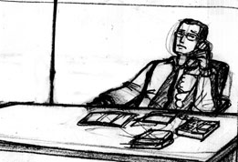  04-20-05  Full shot of Tom on the phone with his legs propped up on his table.  Text Superimposition at the bottom part of the screen:  I’m not sure about this guy. When I say what I think he needs, he backs off. When I ask what he needs, he throws it back to me – like it’s my job to tell him. | Audio File:  Tom:  Well . . . I don’t know . . . I thought you were the expert. I was hoping you would tell me about installing security cameras. | PA COMMENT:  The more I see the feet up, it goes against his feelings. He is a little more receptive, but he is still not feeling good about this. As I look at it, he looks comfortable. He isn’t comfortable yet.
Frame 2A  Description:  One bullet point will appear one at a time to give the learner a chance to digest each one. |  | PA COMMENT: approved
On Screen:  Text Superimposition  What should his behavior tell me?  - Does he want me to take the lead because he doesn’t know what he wants? | SFX:  Pop out sound as each bullet point appears
Frame 2B
On Screen:  Text Superimposition  - Does he want me to back off? | SFX:  Pop out sound as each bullet point appears
Frame 2C
On Screen:  Text Superimposition  - Does he need to feel more comfortable about the sales process? | SFX:  Pop out sound as each bullet point appears
Frame 3  Description:  This shot can be interpreted in two ways. First, as a point-of-view shot of the seller, looking at the wall clock as if he/she is running out of time. Or second, illustrating the increasing boredom of Tom. | PA Comments:  Frame 3 – first idea is better…seller looking at clock. Tom isn’t really bored. | On Client’s Comments:  Ok.
On Screen:  Static Illustration:  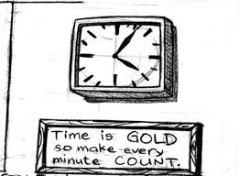  04-20-05  Medium shot from low angle of a wall clock.  Text Superimposition at the bottom part of the screen:  Time to find out! | SFX:  Sound of clock ticking (to building the excitement on whether the seller will make the right choice) | For aesthetic purposes and to drive home the point of this scene, maybe we can add a poster or a plaque under the clock saying “Time is GOLD. So make every minute COUNT.”  PA COMMENT: approved Good idea!
CHOICES FOR SCREEN NO. 14
On Screen:
Static Illustration:
Medium shot from low angle of a wall clock.
ORIGINAL SCRIPT |  | On click, go to Screen #:
A. Fair enough. But I’ll need to ask a few more questions, if that would be all right. |  | Screen 15
B. Well, it can be a big task, depending on your situation. How many entrances do you have? What’s your square footage? |  | Screen 9
COMMENTS:

Back to top

SCREEN NO. 15
Frame 1A
Description:
Focus is on the seller side. This illustration connotes that the seller is finally gaining confidence and the right footing on the conversation.

On Screen:  Static Illustration  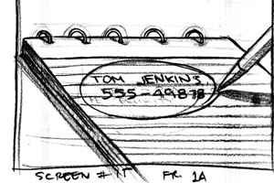  Close up of seller’s notepad where he wrote Tom’s contact data, now with a thick red circle around the note. Part of the seller’s hand with a pen could be seen on the side. | Audio File:  Tom:  Well . . . okay, I guess. What do you want to know? | On Client’s Comments:  Yes, we can take out the hand. The red circle around the note symbolizes that the seller “scored” in terms of his answers.  PA COMMENT: good!
CHOICES FOR SCREEN NO. 15
On Screen:
Static Illustration:

Close up of seller’s notepad where he wrote Tom’s contact data, now with a thick red circle around the note. Part of the seller’s hand with a pen could be seen on the side.

ORIGINAL SCRIPT |  | On click, go to Screen #:
A. What kind of budget do you have in mind for a security system?” |  | Screen 10
B. When would you like to have this installed? |  | Screen 16
C. What kind of security or surveillance do you have now? |  | Screen 8
COMMENTS: Frame 1A How will you show that the seller is doing a better job? (He is not gaining confidence…he’s making the right decisions that get the result he wants – an interested customer.)
How can you show a hand when if will either be male or female? We can’t do that. Can just the pen be seen?

Back to top

SCREEN NO. 16
Frame 1A
On Screen:  Static Illustration  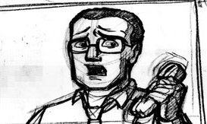  Medium shot of Tom looking shocked and upset. His mouth open and his forehead furrowed. | Audio File:  Tom:  I don’t know. There you go again, putting the cart before the horse. I still don’t even know what this project looks like. | NOTE:  Re-use photos from screen 11  PA COMMENT: I made a previous comment. The look is good, not so much shock as upset and distress.
Frame 1B
On Screen:  Static Illustration  Close up shot of Tom’s hand as he put the phone down. | Audio File:  Tom:  You know, uh, I’m going to have to get back to you. Thanks.  SFX1:  disconnect  SFX2:  dial tone | NOTE:  Re-use photos from screen 11  PA COMMENT: approved
CHOICES FOR SCREEN NO. 16
On Screen:
Static Illustration:

Close up shot of Tom’s hand as he put the phone down.

ORIGINAL SCRIPT |  | On click, go to Screen #:
3-30-05 Changes  @$)0!~###)@!! Oh, I got this far. What kind of probes put him off and what kind move along the process? It’s obviously different for every person. What does Tom’s reluctant behavior tell me? What does Tom’s behavior tell me? I’ll try again! |  | Screen 1
COMMENTS: COPY CHANGE ABOVE

Back to top

SCREEN NO. 17
Frame 1
On Screen:  Static Illustration  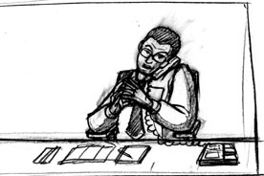  Medium shot of Tom sitting behind his desk, a serious expression on his face. His shoulders folded, leaning on the chair’s armrest, fingertips on both hands pushing at each other – signifying that he’s concentrating on what he’s saying. | Audio File:  Tom:  “Ah, well we have three shifts for the plant. Everyone goes in and out one main set of doors. (fade) | On Client’s Comments:  Tom’s arms won’t be crossed. His shoulders are resting on the chair’s armrest while his hands are lightly clasped together signifying his concentration.  PA COMMENT: very good!
Frame 2
Text Superimposition  Tom Jenkins has become willing to discuss his needs in detail because you have raised receptivity by asking open-end questions about his situation rather than pushing an agenda. Now, it’s a little later in your phone conversation . . . | Audio File:  (lower volume, Tom’s voice as ambient sound)  Tom:  The guard is present for each . . . . “  Mentor/ Narrator:  Tom Jenkins has become willing to discuss his needs in detail because you have raised receptivity by asking open-end questions about his situation rather than pushing an agenda. Now, it’s a little later in your phone conversation . . . | PA COMMENT: On the audio, you wouldn’t have to keep hearing him under…it could slow fade out or to ambient sound of an office or something.
Frame 3
On Screen:  Static Illustration  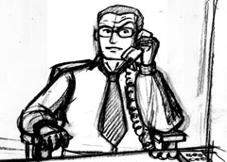  Medium shot of Tom sitting behind his desk, his expression slightly quizzical – an eyebrow raised. Now his arms are crossed – showing a defensive manner. | Audio File:  Tom:  “. . . so, that’s our story, I guess. Uh, what’s the next step? I guess you come in and tear everything up and then send us a huge bill, huh?” | PA COMMENT: good! He’s never going to love the sales process, so he makes a cynical remark. Good expression.
CHOICES FOR SCREEN NO. 17
On Screen:
Static Illustration:

Medium shot of Tom sitting behind his desk, his expression slightly quizzical – an eyebrow raised. Now his arms are crossed – showing a defensive manner.

ORIGINAL SCRIPT |  | On click, go to Screen #:
A. (chuckles) These days, it’s not that bad. But the next step is for me to make an appointment to get a quick survey of your plant. Then, I can have an even better idea of what you would need. |  | Screen 18
B. (chuckles) These days, it’s not that bad. First, let me ask you, is there anything else I should know at this point? |  | Screen 19
COMMENTS: Frame 3: Fine, except his arms shouldn’t be crossed, which signals being defensive. His body should look receptive even though he’s making a joke. The seller has really gotten him involved now.

Back to top

SCREEN NO. 18
Frame 1
On Screen:  Static Illustration  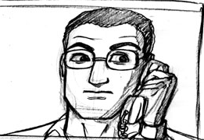  Close up shot of Tom, now more relaxed looking.  Text Superimposition below the screen:  Notice that Tom is now willing to meet, since you have gained some trust and receptivity based on your patience and open probing. | Audio File:  Tom:  “Okay, then, I guess we can set that up now.”  SFX:  (like a choir singing)  Alleluia!  Mentor/ Narrator:  Notice that Tom is now willing to meet, since you have gained some trust and receptivity based on your patience and open probing. | PA COMMENT: excellent
CHOICES FOR SCREEN NO. 18
On Screen:
Static Illustration:
SELECTED SCRIPT |  | On click, go to Screen #:
A. Good. Tom, when would your boss be available to meet with me? |  | Screen 20
B. Good. Tom, who will be making the decision about hiring my company? |  | Screen 21
C. Good. Tom, who do you think should be at that meeting? |  | Screen 23
COMMENTS:

Back to top

SCREEN NO. 19
Frame 1A
Rationale:
I divided this scene into three parts since the voice over is very long. The photos will also show the progression of Tom’s expressions – ultimately arriving in a favorable disposition.

On Screen:  Static Illustration  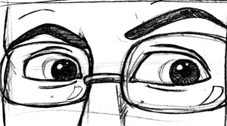  Extreme close-up of Tom’s eyes. | Audio File:  Tom:  (pauses) Well, just that, if this goes well, we have four other facilities in the state.
Frame 1B
On Screen:  Static Illustration  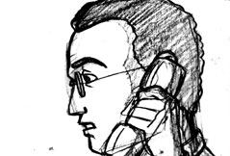  Close up shot of Tom’s profile. | Audio File:  Tom:  I’ve seen them all. They all need updated security, in my estimation, but we really don’t talk with each other that much. You might contact those facilities.
Frame 1C
On Screen:  Static Illustration  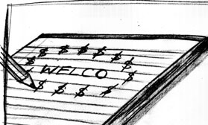  04-20-05 | Audio File:  Tom:  So . . . well, if this works out, you could be in line to work on the others. That might make a difference in how you make your proposal.  Mentor/ Narrator:  You thank Tom for that piece of information and ask him if there’s anything else you should know. He says there isn’t. | PA COMMENT: The first two are fine. Here’s a thought: What if instead of the smile we switch to the learner’s note with the Welco name and the pencil has put in dollar signs around the name?  PA COMMENT: approved
CHOICES FOR SCREEN NO. 19
On Screen:
Static Illustration:

Extreme close-up of Tom’s mouth – smiling.

ORIGINAL SCRIPT |  | On click, go to Screen #:
You thank Tom for that piece of information and ask him if there’s anything else you should know. He says there isn’t. |  | Screen 22
COMMENTS: I have to go with the original script here because the learner needs the answer to the question.

Back to top

SCREEN NO. 20
Frame 1A

On Screen:  Static Illustration  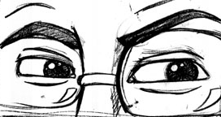  Extreme close up of Tom’s eyes narrowing. | Audio File:  Tom:  (gets very cold)  I don’t know. | PA COMMENT: yes! good
Frame 1B
On Screen:  Static Illustration  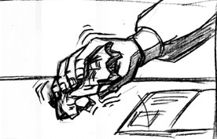  Close up of Tom’s free hand wringing the company brochure. | Audio File  Tom:  My boss won’t be at that meeting. He says he’s too busy to get involved in that right now. He’s leaving everything up to me. I don’t like it, but that’s how it is. | On Client’s comments:  Yes, wringing – crumpling the brochure in preparation to throw it away.  PA COMMENT: approved
Frame 1C
On Screen:  Static Illustration  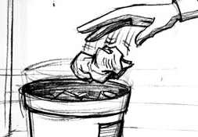  Medium shot of Tom dropping the crumpled brochure into the trashcan.  Text Superimposition below the screen:  But he said his boss told him to call. I thought his boss was the key person! I guess I shouldn’t make assumptions about who’s the decision maker. | Audio File  Tom:  Maybe I should get back to you to set it up. I have to make a few other calls.  SFX1:  Line cut/ clicking  SFX2:  dial tone | PA COMMENT: approved
CHOICES FOR SCREEN NO. 20
On Screen:
Static Illustration:

Medium shot of Tom dropping the crumpled brochure into the trashcan.

Text Superimposition below the screen: 3-30-05 Changes
But he said his boss told him to call. I thought his boss was the key person! Now he thinks I was trying to go over his head. I shouldn’t make assumptions about who’s the decision maker.

ORIGINAL SCRIPT |  | On click, go to Screen #:
He’s not going to call back, is he? Sighh . . . I have to start over. |  | Screen 1
COMMENTS: COPY CHANGE ABOVE

Back to top

SCREEN NO. 21
Frame 1A
On Screen:  Static Illustration  Extreme close up of Tom’s eyes narrowing. | Audio File:  Tom:  I’m not sure what kind of question that is. I wouldn’t worry about that right now. | NOTE:  We can re-use photo from Screen no. 20 Frame 1A.  PA COMMENT: approved
Frame 1B
On Screen:  Static Illustration  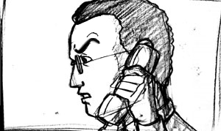  04-20-05  Close up shot of Tom’s profile. | Audio File:  Tom:  Let’s just figure out a time when you and I can meet. | NOTE:  We can re-use photo from Screen No. 19 Frame 1B.  PA COMMENT: approved…be sure he looks irritated by what was said.  PA COMMENT: approved
Frame 1C
Description:
Focus goes to the seller – to highlight his/her “narrow escape.”
On Screen:  Static Illustration  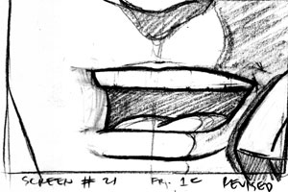  04-20-05  Extreme close up of seller’s hand loosening his/her collar.  Let’s retain focus on Tom. Extreme Close Up of Tom’s mouth as he talks on the phone. | Audio File:  Tom:  Let’s just figure out a time when you and I can meet.  SFX:  Loud gulping sound | On Screen Option:  Let’s retain focus on Tom. Extreme Close Up of Tom’s mouth as he talks on the phone.  On Client’s Comments:  Yes, we can use a whistling SFX.
CHOICES FOR SCREEN NO. 21
On Screen:
Static Illustration:

Extreme close up of seller’s hand loosening his/her collar.

ORIGINAL SCRIPT |  | On click, go to Screen #:
Whoa! I almost blew it. It’s good to figure out who the decision maker is, but maybe a different way of asking the question would be better. |  | Screen 18
COMMENTS:Frame 1C How will you show this without a gender problem?? You can’t really show hands or a shirt loosening without indicating male or female hands. And shirt opening isn’t really a female gesture. They’re collars aren’t buttoned up. Instead of loud gulping (or with it) or a whistle. You could also put up the letters on screen “W-h-h-h-ew!”

Back to top

SCREEN NO. 22
NOTE: This scene is exactly the same as SCREEN NO.18 except for link out to choice
Frame 1
On Screen:  Static Illustration  Close up shot of Tom, now more relaxed looking.  Text Superimposition below the screen:  Notice that Tom is now willing to meet, since you have gained some trust and receptivity based on your patience and open probing. | Audio File:  Tom:  “Okay, then, I guess we can set that up now.”  SFX:  (like a choir singing)  Alleluia!  Mentor/ Narrator:  Notice that Tom is now willing to meet, since you have gained some trust and receptivity based on your patience and open probing. | PA COMMENT: approved
CHOICES FOR SCREEN NO. 22
On Screen:
Static Illustration:

SELECTED SCRIPT |  | On click, go to Screen #:
A. Good. Tom, when would your boss be available to meet with me? |  | Screen 20
B. Good. Tom, who will be making the decision about hiring my company? |  | Screen 24
C. Good. Tom, who do you think should be at that meeting? |  | Screen 25
COMMENTS: PA COMMENT: I DON’T KNOW IF IT MATTERS IN YOUR DESIGN, BUT WHEN I CLICK ON SCREEN 25 ABOVE, IT TAKES ME TO “B” SCREEN 24. – Hyperlink updated (04-24-05)

Back to top

SCREEN NO. 23
Frame 1A
On Screen:  Static Illustration  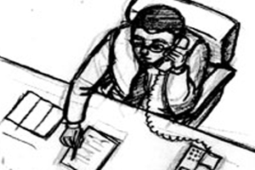  04-20-05  Medium shot of Tom from a high angle. He’s leaning on his desk, the brochure in front of him and he’s ready to take some notes. | Audio File:  Tom:  At this point, just me. I don’t necessarily like it, but my boss wants me to handle this. He’s too busy. | PA COMMENT: nice shot  Needs name of the security company placed in the brochure on the desk  Winston Security Systems
Frame 1B
Text Superimposition  You’ve successfully worked with someone suspicious of salespeople and who doesn’t like the buying process. You did it by going slowly with Q2 behavior, finding out about Tom’s needs and holding off presenting your product and service at this point. Building some trust and creating the third pathway to the sale puts you in a better position to sell this reluctant buyer. Good job. | Audio File:  Tom:  That’s why I want you to give me the straight story on this.  Mentor/ Narrator:  You’ve successfully worked with someone suspicious of salespeople and who doesn’t like the buying process. You did it by going slowly with Q2 behavior, finding out about Tom’s needs and holding off presenting your product and service at this point. Building some trust and creating the third pathway to the sale puts you in a better position to sell this reluctant buyer. Good job.
Frame 2
On Screen:  Static Illustration  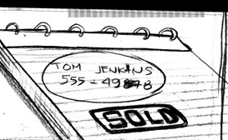  Close up of seller’s notepad with Tom Jenkin’s contact information encircled with thick red pen. Now stamped with “SOLD.” The word SOLD in different fonts and sizes pop out as additional animation. | SFX:  Crowd cheering with applause | PA COMMENT: approved
Frame 3
USE CRASH ZOOM TRANSITION TO CONNOTE PASSAGE OF TIME.  On Screen:  Static Illustration  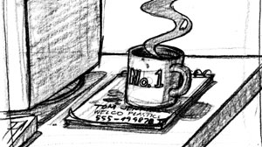  Medium shot of seller’s desk. Notepad with Tom Jenkin’s contact info looks old, it has coffee stains over it and a different mug (with NO.1 design) is now using it as a coaster. | SFX1:  Sound of typing on computer keyboard.  SFX2:  Sound of incoming email. | PA COMMENT: approved
Frame 4A
On Screen:  Static Illustration  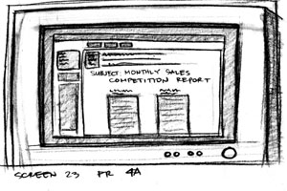  Close up of computer screen – On the subject of the email: Monthly Sales Competition Report | SFX:  Heart beat starting to go fast | PA COMMENT: approved
Frame 4B
On Screen:  Static Illustration  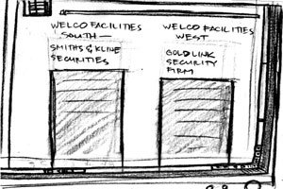  Extreme close up of two columns on the report:  Welco Facilities South – Brookline Security  Welco Facilities West – Goldlink Security Firm  Text Superimposition below the screen:  I did a good job with Jenkins, but I should have asked for more information! Argghh.  PA COMMENT: Change Smiths&Kline to Brookline Security (change reflected above in text) | SFX:  Heart beating faster | PA COMMENT: approved
Frame 4C
On Screen:  Static Illustration  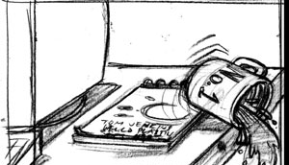  Medium shot of the seller’s new coffee mug as he/she accidentally spilled its content because of his/her surprise and breaking it. | SFX1:  Sound of mug toppling over  SFX2:  Glass breaking | PA COMMENT: approved
Frame 4D
On Screen:  Static Illustration  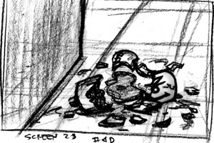  04-20-05  Close up shot from high angle of the broken NO.1 coffee mug on the floor. | SFX:  “Boo” disappointed crowd | PA COMMENT: approved  No. 1 design still recognizable – for irony  PA COMMENT: approved nice touch!
CHOICES FOR SCREEN NO. 23
DONE

COMMENTS: These are good visual ideas! I like the way you show that he lost those other jobs. You might put an X next to each one. (However, my X’s in this document mean that’s my choice!)

CAN THE PARAGRAPH BEGINNING “You’ve successfully worked with . . .” ABOVE BE NARRATED OUT LOUD?

Back to top

SCREEN NO. 24
Note: This scene is exactly the same as SCREEN NO. 21 except for link out to choice
Frame 1A
On Screen:  Static Illustration  Extreme close up of Tom’s eyes narrowing. | Audio File:  Tom:  I’m not sure what kind of question that is. I wouldn’t worry about that right now. | NOTE:  We can re-use photo from Screen no. 20 Frame 1A.  PA COMMENT: approved
Frame 1B
On Screen:  Static Illustration  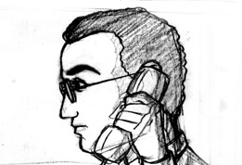  04-20-05  Close up shot of Tom’s profile. | Audio File:  Tom:  Let’s just figure out a time when you and I can meet. | NOTE:  We can re-use photo from Screen No. 19 Frame 1B.  PA COMMENT: approved
Frame 1C
Description:
Focus goes to the seller – to highlight his/her “narrow escape.”

On Screen:  Static Illustration  04-20-05  Extreme close up of seller’s hand loosening his/her collar.  Let’s retain focus on Tom. Extreme Close Up of Tom’s mouth as he talks on the phone. | Audio File:  Tom:  Let’s just figure out a time when you and I can meet.  SFX:  Loud gulping sound | On Screen Option:  Let’s retain focus on Tom. Extreme Close Up of Tom’s mouth as he talks on the phone.  On Client’s Comments:  Yes, we can use a whistling SFX.  PA COMMENT: approved
CHOICES FOR SCREEN NO. 24
On Screen:
Static Illustration:

Extreme close up of seller’s hand loosening his/her collar.

ORIGINAL SCRIPT |  | On click, go to Screen #:
Whoa! I almost blew it. It’s good to figure out who the decision maker is, but maybe a different way of asking the question would be better. |  | Screen 22
COMMENTS: Same comments as with 21 about showing hands and collar.

Back to top

SCREEN NO. 25
Frame 1A
On Screen:  Static Illustration  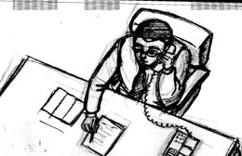  Medium shot of Tom from a high angle. He’s leaning on his desk, the brochure in front of him and he’s ready to take some notes. | Audio File:  Tom:  At this point, just me. I don’t necessarily like it, but my boss wants me to handle this. He’s too busy. | NOTE:  Repeat Screen No. 23 Frame 1A.  PA COMMENT: approved
Frame 1B
Text Superimposition  You’ve successfully worked with someone suspicious of salespeople and who doesn’t like the buying process. You did it by going slowly with Q2 behavior, finding out about Tom’s needs and holding off presenting your product and service at this point. Building some trust and creating the third pathway to the sale puts you in a better position to sell this reluctant buyer. Good job. | Audio File:  Tom:  That’s why I want you to give me the straight story on this.  Mentor/ Narrator:  You’ve successfully worked with someone suspicious of salespeople and who doesn’t like the buying process. You did it by going slowly with Q2 behavior, finding out about Tom’s needs and holding off presenting your product and service at this point. Building some trust and creating the third pathway to the sale puts you in a better position to sell this reluctant buyer. Good job. | NOTE:  Repeat Screen No. 23 Frame 1B.  PA COMMENT: approved
Frame 2
On Screen:  Static Illustration  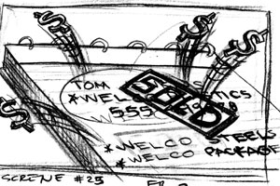  04-20-05  Close up of seller’s notepad with Tom Jenkin’s contact information encircled with thick red pen. Now stamped with “SOLD.”  Right below the first note is a listing of two other Welco facilities. Dollar signs are popping out as additional animation.  Text Superimposition below the screen  And because you probed for more information, you have leads at two other Welco Plastics facilities. This company could become a long-term client! | SFX1:  Cash register ringing  SFX2:  Crowd cheering with applause  Mentor/ Narrator:  And because you probed for more information, you have leads at two other Welco Plastics facilities. This company could become a long-term client! | PA COMMENT: approved Good!
CHOICES FOR SCREEN NO. 25
DONE

COMMENTS:
CAN THE PARAGRAPH BEGINNING “You’ve successfully worked with . . .” ABOVE BE NARRATED OUT LOUD? ALSO, THE NEXT COPY BLOCK BEGINNING “And because you ….” AUDIO

Back to top

