
1191 Huntington Drive, Suite 188
Duarte, CA 91010, USA
Phone: (626) 930-0160
Fax: (626) 628-3885
Selecting Voiceovers
Title | Hourly Fishbone
Online Story Board (for reference to expressions)

Character profiles: Hourly Fishbone
Character Look |  |  | 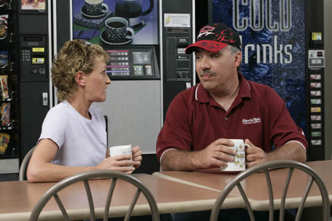
Name | Coordinator | Bob – Jacket Operator | Bill | Nancy
Lines for Voice Over | 2 lines  Approx. 1 minute. | 1 line only  Approx. 20 seconds | 5 lines  Approx. 2 minutes. | 4 lines  Approx. 2 minutes.

# | Character | Voice Over Line | Talent Selected
 | Coordinator | Unfortunately, I think you need to shutdown your cabler and find out what is causing the rough finish. | Johnny Winningham  Phone: 213 321 3265, 818 7524750  Email: winninghamjohnny@hotmail.com
 | Bob – Jacket Operator | I just finished setting up the line to run your products. Don’t tell me I need to retool again to setup for another product! | Bob Rumnock  email: bobrumnock@yahoo.com  p: 310-839-8314  cp: (323) 842-2545
 | Coordinator | We have a couple of hot orders running and we can’t stop production. We have to change the Jacket line over or we will miss our shipping dates! | Johnny Winningham  Phone: 213 321 3265, 818 7524750  Email: winninghamjohnny@hotmail.com
- End Scene -
 | Bill | What seems to be the problem? | John : john@diegoaudio.com  (Referred by Melanie Taylor)  http://www.thankyouforholding.com/demos.php
 | Nancy | That’s strange. If it’s the same problem over and over again… then why is it still happening? | Jean St. James  phone: (310) 663-9989  310.839.8314.  cell: 310.663.9989  email: jean@itaproductions.com
 | Bill | That sounds great. Sometimes the real reasons for the problems are not obvious and the best solution is hard to get to. Often problems fall into different categories. For example…. (Bill continues to tell a story of his experience)  (his voice fades out) | John : john@diegoaudio.com  (Referred by Melanie Taylor)  http://www.thankyouforholding.com/demos.php
 | Nancy | I see what you’re saying. Grouping them in that way would help you determine what you need to focus on. | Jean St. James  phone: (310) 663-9989  310.839.8314.  cell: 310.663.9989  email: jean@itaproductions.com
 | Bill | What have you found so far? | John : john@diegoaudio.com  (Referred by Melanie Taylor)  http://www.thankyouforholding.com/demos.php
 | Bill | Wow! You have some serious problems. (laughing!) | John : john@diegoaudio.com  (Referred by Melanie Taylor)  http://www.thankyouforholding.com/demos.php
 | Nancy | Let me see. (Pauses)  How would you define the overall the overall problem? | Jean St. James  phone: (310) 663-9989  310.839.8314.  cell: 310.663.9989  email: jean@itaproductions.com
 | Bill | Now you need to categorize the causes. How would you go about doing that or, in other words, laying them out? | John : john@diegoaudio.com  (Referred by Melanie Taylor)  http://www.thankyouforholding.com/demos.php
 | Nancy | How does laying out the problem in this format help you? | Jean St. James  phone: (310) 663-9989  310.839.8314.  cell: 310.663.9989  email: jean@itaproductions.com
- End Scene -

