
1191 Huntington Drive, Suite 188
Duarte, CA 91010, USA
Phone: (626) 930-0160
Fax: (626) 628-3885
ABC Co. Version 5
Title | Hourly Fishbone
Original Document
Topic | Too Much Downtime
Problem Solving Tool | Fishbone Diagram
Audience | Hourly Level
Learning Objectives | Understanding the Cause & Effect Relationship (categorizing the many potential causes of a problem in an orderly way and identifying root causes)
Document Type | Content Script/ Structure
Date | 05-15-06
Instruction | Ctrl + Click to follow links

Character profiles:

Coordinator | Bob – Jacket Operator | Bill | Nancy

For Sketching – highlighted in gray
Approximately – 21 sketches
Perspective: Characters are looking straight at you

→ Start of SBL Storyboard

Screen Number 1
Copy | Photo/ Graphic Concept/ SFX | Place Comments Here
You are a Cable operator.  Bob, a Jacket Operator approaches you and tells you that he noticed a scuffed finish on the cable core that is coming from your lines. Bob also indicates that the first reel of core that he ran from your line failed quality standards because of too many AC’s.  He asks YOU to DMT the other three cable reels that you produced on this shift because they look like they have a rough finish too. | Bob holding some cable with a request for explanation look on his face. | Place Comments Here

Back to top

Screen Number 1b
Copy | Photo/ Graphic Concept/ SFX | Place Comments Here
The Coordinator happens by and overhears your conversation. He interrupts. | Coordinator with Bob looking at a shutdown switch. Coordinator with a concerned look on her face.  Coordinator:  Unfortunately, I think you need to shutdown your cabler and find out what is causing the rough finish. | Place Comments Here
You are not happy about having to shut your line down because every time you do it, you wind up running the cablers on the other side of the plant until maintenance has a chance to fix your machine. | Coordinator with Bob watching you shut the line down – serious faces. (silhouette of a hand on the shut down switch)  You make a groaning noise as you do it. | Place Comments Here
Bob is not happy because he just got finished setting up the jacket line for your products. | Focus on Bob who looks frustrated.  Bob talking:  I just finished setting up the line to run your products. Don’t tell me I need to retool again to setup for another product! | Place Comments Here
The Coordinator is also not happy about having to shut the line down. | Focus on the Coordinator who looks frustrated.  Coordinator responding to Bob:  We have a couple of hot orders running and we can’t stop production. We have to change the Jacket line over or we will miss our shipping dates! | Place Comments Here
You decide you’re tired of being bounced from line to line all the time. This is the third time this week that you had to shut your line down for one reason or another. All of this downtime is really starting to add up, and it is obviously starting to impact a lot of people, including the customer who won’t receive the product that they ordered on time, again!  You want to get to the bottom of the problem once and for all. | Silhouette of a head with a thought bubble:  Let me look at the DMR and talk with someone in Maintenance. | Place Comments Here

Back to top

Screen Number 1c
Copy | Photo/ Graphic Concept/ SFX | Place Comments Here
You go through the DMR, pull up records of recent downtimes, look at reasons for the downtimes, and DMTs.  Maintenance provided you with some additional information regarding repair history for the last 2 months on that cabler. | * see below | Place Comments Here
Photo/ Graphic Concept/ SFX

Computer Screen

(Zoom in on operator using the DMR (computer).

Zoom in on DMR cumulative reports screen including downtimes.

Zoom in on screen showing details of downtime.

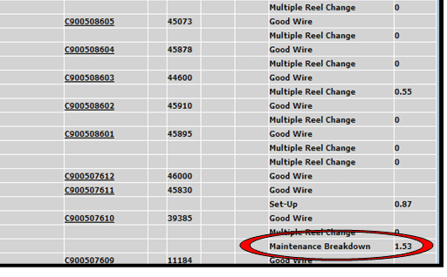
- - - - - - - - - - - - - - - -
* screens reference link (ctrl + click to open)

Records displayed with dates of the previous shutdowns.
5/05/06 Cabler Down: Downtime Code 631 Maintenance Breakdown: worn eyelets replaced in bow

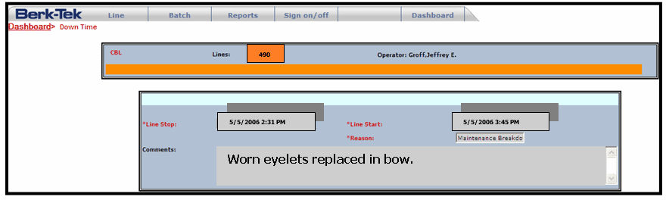

5/08/06 Cabler Down: Downtime Code 631 Maintenance Breakdown: guide pulleys realigned

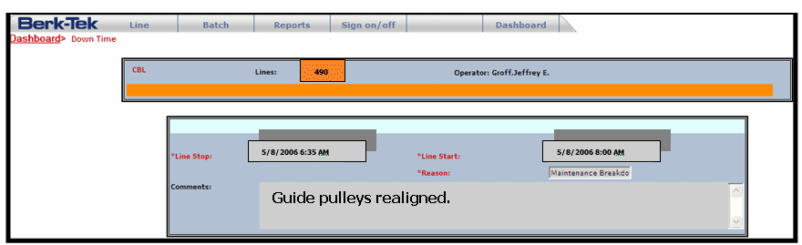

5/10/06 Cabler Down: Downtime Code 671 Operator Maintenance: closing die replaced

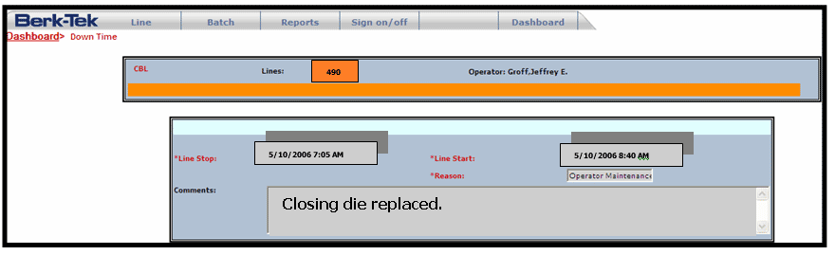

5/14/06 Cabler Down: Downtime Code 631 Maintenance Breakdown: replaced some questionable eyelets in bow

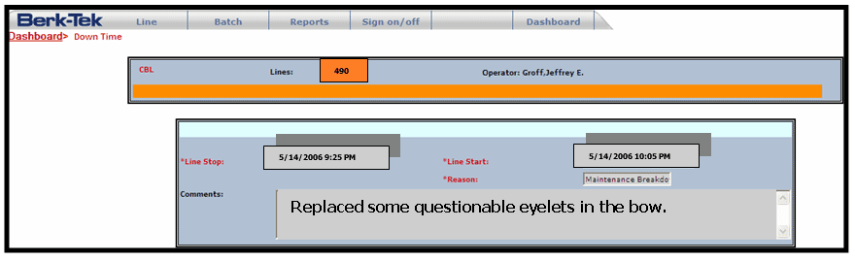

*** Data Sheet Screenshots:
http://home.vftraining.net/areodique/ABC Co./content_concepts/Fishbone%20SBL%20Data%20Screenshots.doc

Back to top

Screen Number 1d
Copy |  | Photo/ Graphic Concept/ SFX |  | Place Comments Here
 |  | Hand on the computer mouse – thought bubble  ”Wow. A lot of this data reflects the same problems happening over and over again. I wonder what’s causing these recurring problems?” |  | Place Comments Here
Choices |  | On Click, go to Screen # | Feedback/ Place Comments Here
 | Maintenance is always putting band-aids on the problems; they really don’t fix the problems. | Screen 1d | (Incorrect choice)  It’s easy to blame others but more than likely, there is more to it than that. Try again.  Why would selecting Choices A & C take you back to the beginning? Why would they not just return you to Screen 1D?  (Our recommendation is “try again.”)
 | I don’t have enough detail yet. These records are a good start but I need to probe a little further. | Screen 1e | (Correct choice) Feedback:  Good choice! Getting more detail will help you get a more accurate picture of what’s happening.  Click to get more details.  (Move to Screen 1e)
 | It’s the operator on the other shift. He’s always messing with the line. I’m going to talk with him. | Screen 1 | (Incorrect choice) Feedback:  Confronting another operator without a clear understanding of the issues may cause more problems. He is likely as frustrated as you.  (Back to Screen 1)
Comments General Comments Here:

Screen Number 1e
Copy | Photo/ Graphic Concept/ SFX | Place Comments Here
You explored details for each downtime, DMT and maintenance issue on your cabler.  After reviewing the information, the following catches your attention.  Operator PM is extremely overdue. (Man)  Operator PM was performed insufficiently. (Man)  Worn eyelets in the bow have been replaced five times in the past month. (Machine)  Pulley was out of alignment twice in the past month (Machine)  The settings used were from an out-of-date process sheet. New material is larger in diameter so product could not clear closing die without jumping out of sequence. Also, tensions were off. (Method)  Product received from Twist is damaged (Materials)  ---------------------------- ------------------------  Note on interactive design:  We can ask the participant to click the  problems and let him/her identify the  problems from each record.  For example, participant will be asked to  open three folders (These would be links), in each folder is a list  Of notations on problems. We can ask participant to click the problem relevant to the issues.  Each problem clicked, a feedback is provided.  “Good, this is a problem related to people or  this is problem causing breakdown in machine”.  He/she then completes reviewing the 4 folders.  This step is important because in later Scenes,  We’re not sure what is supposed to be happening here. | (Zoom in on a pile of folders with maintenance records. Records displayed four dates of the previous shut downs.  (Same Downtime information as before, plus following additional information)  Graphic of OPM schedule  DMTs:  5/5/06 DMT Code 305: Acs  5/8/06 DMT Code 331: Damaged Online  5/10/06 DMT Code 202: Cable Out of Sequence  5/14/06 DMT Code 305: ACs  (Post notes, or notations are zoomed in the records, keep the record files open. Show notations on some problems).  -------------------------------------------------- -  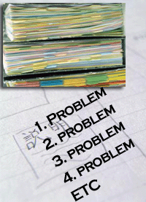  (Click next – to Screen 1g) | Place Comments Here

Screen Number 1g
You are really frustrated by the situation and decide to go get a coffee to clear your head before you look further into the problem. | Picture of operator at coffee machine.  SFX: Sound of coffee being dispensed. | Place Comments Here
(click next – to Screen 2) | (move to screen 2)

Back to top

Screen Number 2
Copy | Photo/ Graphic Concept/ SFX |  | Place Comments Here
While getting your coffee, you share the situation and some of your findings with some of the other operators in the break room. | Some operators sitting at a table having some coffee and talking. (misc. people)  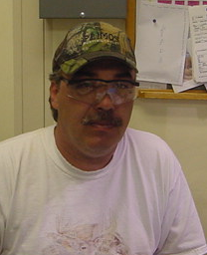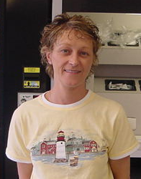 |  | Place Comments Here
One of your fellow operators is Bill. He overhears the conversation and approaches you. | Bill with his coffee and an interested look on his face.  Bill:  What seems to be the problem?  You answered. “It’s not quite clear to me. It seems to be the same problem ... over and over again. |  | Place Comments Here
One of your fellow operators is Nancy. She adds to the conversation. | You, Bill and Nancy standing together with your coffee.  Nancy (looking at you):  That’s strange. If it’s the same problem over and over again… then why is it still happening? |  | Place Comments Here
You reply: “Exactly – maintenance has fixed the machine each time. But it’s bigger than maintenance. That’s why I’m looking into it.”  (Bill continues story, but a fade to the next scene below) | Bill with his coffee and an interested look on his face.  Bill:  That sounds great. Sometimes the real reasons for the problems are not obvious and the best solution is hard to get to. Often problems fall into different categories. For example…. (Bill continues to tell a story of his experience)  (his voice fades out, focus on your face with bubble) |  | Place Comments Here
You: while Bill is talking a thought struck you: “That’s it! I need to find a way to categorize the problems.” | (Silhouette of head with thought bubble)  You: while Bill is talking a Bubble came to your mind: “That’s it! I need to find a way to categorize the problems.” |  | Place Comments Here
 | Focus on Nancy with explaining face  Nancy:  ”I see what you’re saying. Grouping them in that way would help you determine what you need to focus on. ” |  | Place Comments Here
 | On Click, go to Screen # | Click to Screen 3
Comments General Comments Here:
NOTE: You can add more background content in the records, not just 4 topics but 12 issues, in notations or post notes, whichever way is real. The 12 topics represent the 4 Ms.

Back to top

Screen Number 3
Copy |  | Photo/ Graphic Concept/ SFX |  | Place Comments Here
 |  | Bill with his coffee. Looking straight with a questioning face.  Bill:  What have you found so far? |  | Place Comments Here
Choices |  | On Click, go to Screen # | Feedback/ Place Comments Here
 | The maintenance breakdown downtime code repeats over and over again so obviously it’s a maintenance issue. | Screen 1e | (Feedback)  Is it really just a maintenance issue?  Although the maintenance breakdown code appears most often, a lot of the time problems are given that code incorrectly. Take a closer look at the data.  Can we make it so it takes the learner to a screen that is just like Screen 1e, but this screen has a “try again” button they can click.
 | These problems occur every three or four days at regular intervals. Apparently the machine gets tired and needs a little TLC every few days.  (feedback sent by Jeff 05-04-06 email) | Screen 2 | (Feedback)  Not quite. Try to listen to what Bill & Nancy are saying.  (go back to listen to Bill & Nancy).
 | There are multiple problems, falling into different categories, affecting each other. | Screen 4 | (Feedback)  You are right. There are multiple reasons  for the problem, including OPMs being overdue, worn eyelets, improper set-ups, damaged input reels, etc. (see DMR data above)  (summary the few key problems)  (Click to continue – screen 4)
Comments General Comments Here:

Back to top

Screen Number 4
Copy |  | Photo/ Graphic Concept/ SFX |  | Place Comments Here
You look at Bill and Nancy and show them the list you prepared on a crumpled paper. This list shows key words of the problem areas shown in the data. (only short 2-3 words each no.)  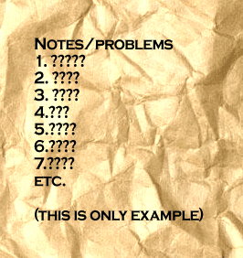 |  | Hand pointing on a piece of paper  (You)  This is what I gathered so far.  This is very rough. |  | Place Comments Here
Bill looks at the paper and jokingly says: “Wow! You have some serious problems! |  | Bill with a big smile on his face  (Bill)  Wow! You have some serious problems. - laughing!)  (Click Next) |  | Place Comments Here
Nancy is more helpful!  Glances at your list. |  | (Nancy with Bill both looking at you straight face – Nancy with one eyebrow raised)  Nancy:  Let me see. (Pauses)  How would you define the overall the overall problem? |  | Place Comments Here
You standing there. |  | Too much downtime. |  | Place Comments Here
 |  | Bill says: “Now you need to categorize the causes. How would you go about doing that or, in other words, laying them out?”  Click Next. |  | Place Comments Here
 |  |  | On Click, go to Screen # |  | Place Comments Here
Step 1 | “Too much downtime” appears at the head of the fish.  Can we explain here the 4 Ms?  Then, the learner is instructed to drag each problem into the most appropriate category. Feedback is provided after each click and drag. Instructions regarding what to do next are provided.  The learner does this several times until problems are all dragged to the yellow portion.  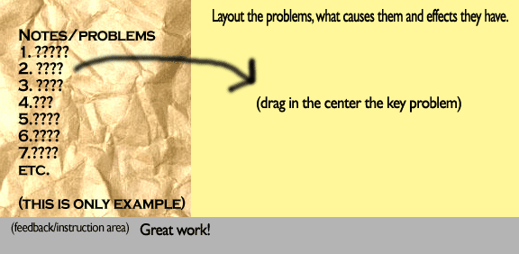  Click next |  | (Click Next) |  | Place Comments Here
Step 2 | After categorizing all the problems, a complete fishbone diagram appears.  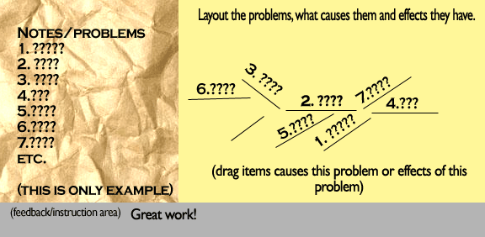  Click next |  | (Click Next) |  | Place Comments Here
 |  |  | Click Next |  | Screen 5
Comments General Comments Here:

Screen Number 5
Copy |  | Photo/ Graphic Concept/ SFX |  |  | Place Comments Here
 |  | (Nancy with a questioning face)  How does laying out the problem in this format help you? |  |  | Place Comments Here
Choices |  |  | On Click, go to Screen # | Place Comments Here
A | It helps me to see how the various problems are related to one another. Laid out this way it looks like a fishbone. |  | Screen 6 | (Feedback)  Knowing the interrelations of causes and effects and laying out as Fishbone, makes it easy to attack a problem.  (click Forward) (Forward to screen 6 )
B | It makes the problem clearer. |  | Screen 5 | Does it really make the problem any more clear?  Try again. (click here)
C | I know who is at fault! |  | Screen 4 | Feedback:  Is placing blame the most effective way to go?  (click back) (Black to screen 4)  Do we really want them to have to go all the way back to screen 4?

Screen Number 6 Ending
Correct Response:
Congratulations!
The Fishbone approach to problem solving helps you understand …. (add content)
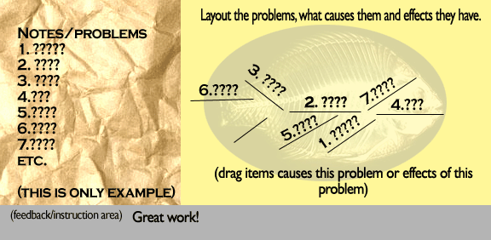
You have successfully completed the learning! Good job!. You may close this window now.
(End of the SBL)

Comments General Comments Here:
Suggestion:
Let us separate in another exercise, not an SBL, to ask participants to group into the right categories the problem areas or solutions under the 4 Ms. Right after the SBL, we can present an exercise. Nonetheless, the 4 Ms are already mentioned here.
Click below for an example only on how to execute this in a Flash.
(We would rather have the learner categorize into the 4Ms within the exercise in the SBL. Otherwise they don’t know what category they’re dragging the problems into. Further, we believe a separate exercise would be redundant.)

How to add the 4 M interactive exercise.
Learners will be asked to match the problems to the categories. Once the match is completed, the game/exercise is completed.
THIS IS ONLY AN EXAMPLE:
http://vftraining.net/acme/Pa/FLASH%20DEVELOPMENT/advanceflash/m4_Dimensional_dragdrop/PA_dimensionalMethod.htm
Before they are asked to perform the exercise, the learner will be provided a short text explanation on the importance of the 4 Ms in context of the Fishbone. Then the learner is asked to do the exercise. Based on the problems and solutions discovered in the SBL, the learners will be asked to drag and drop the problem items into 4 M categories.

