
1191 Huntington Drive, Suite 188
Duarte, CA 91010, USA
Phone: (626) 930-0160
Fax: (626) 628-3885
Creative Brief Example
Project Title | The Basics of Fair Housing
Company | CallSource
Client Contact Information
Client Website (if available) | Callsource.com
Document type | Creative Brief [Version 01]
LMS URL (if available) | Learn.com
Date Modified | 01-24-08
Instructions | - Fill up details  - Place ‘none’ if not available  - Upload references to client FTP folder

No. | Item | Details | Link to Reference  (if available) | Comments/ Status
 | Overall Objectives, Goals and Processes | - Create total look and feel, aesthetic design for banners, pages, logos, icons and buttons of the program.  - Utilize the approved creative brief as standard for production control.  - Client decision makers will approve and sign off the final creative brief.  - Required date of approval:  - Future changes after approval version will require re-scoping and therefore will increase the cost of the project. | 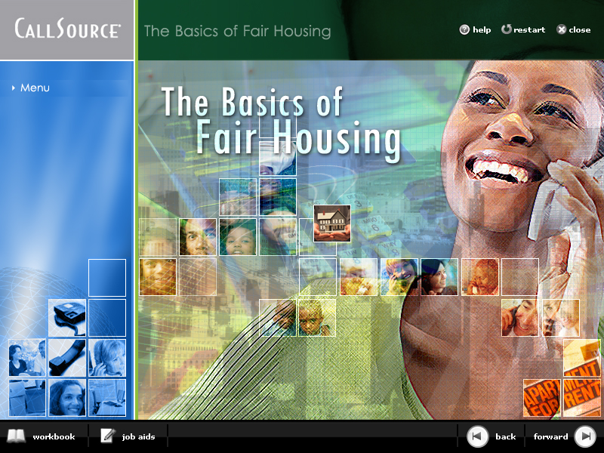
 | Considerations
 | Client current website
 | LMS (if applicable)
 | Competitors/ Benchmark Sites
 | Definition of Users | Mostly women. Leasing Professions
 | LMS Limitations/ Requirements/ Specifications | Learn.com References | CallSource FTP:  /home/vftlps/public_html/callsource/Learn.com Technical Docs/
 | Interface Mock-up
 | Legal Branding | Use of the following:  a. Copyright  b. Disclaimers  c. Logos  d. Branding  CallSource @ 2008 |  | For discussion
 | Interface Elements
 | Photo Style(s)  a. Overlay, Layered, Color Treated for styled background images  b. Boxed approach for inside pages | 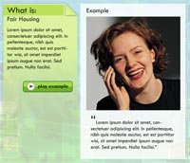
Fonts:
  - Buttons: Verdana 10px Bold
  - Banner Title: Levenim MT 20px
  - Modules: Levenim MT 14px
  - Intro Page Title: Tw Cen MT Condensed [varies]px
  - Body: Levenim MT 14px

 | Charts, Bars, Stats Style(s), Bullets | 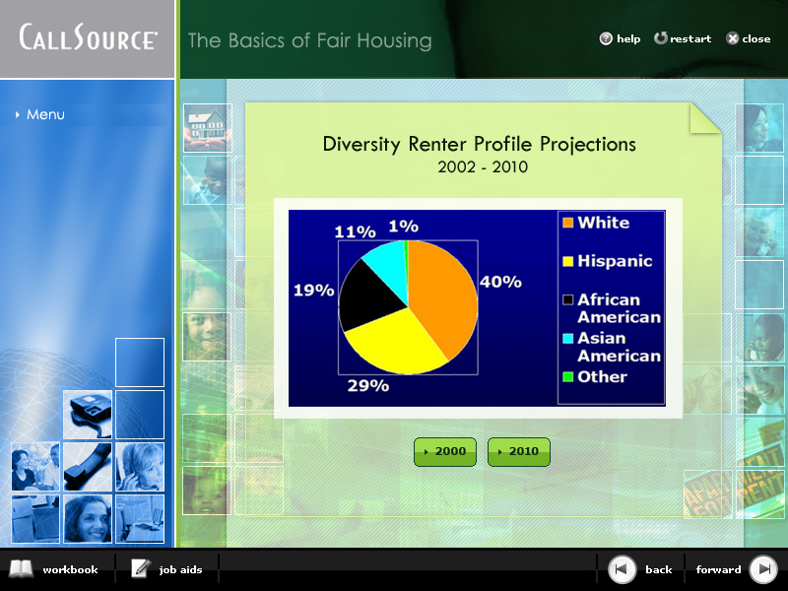 | Chart layout | What are the types of charts, diagrams?
 | Main Menu  Sub Menu  Prompts/Hints | 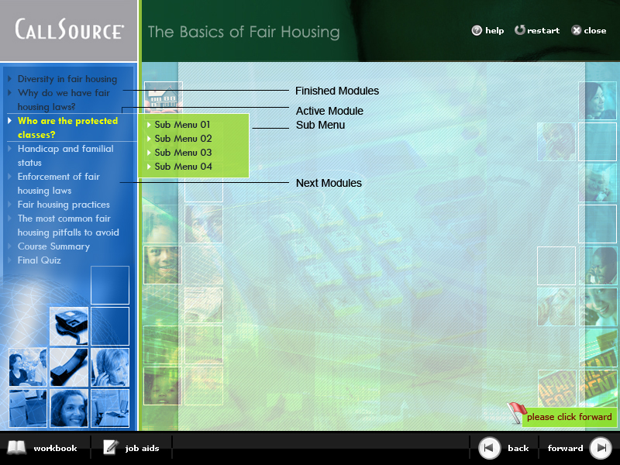 | Navigation
 | Icons  List of required icons:  a. forward  b. back  c. close  d. help  e. restart  f. workbook  g. job aids  Button Style(s)  a. Font(s): Verdana 10px  b. Graphics: Button Style  c. Button labels:  Yes, No, Submit, Play Example | 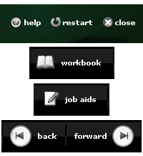  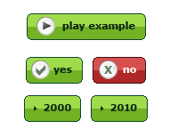
 | Download Document Style(s) | Standard list:  a. PDF  b. Word Document  c. Excel  d. PowerPoint |  | Is this required or will it point to existing resources of CallSource?
 | Slide Shows  a. Interface  b. Navigation buttons  c. Page layout  d. Fonts  e. Image style(s)  f. Text display  g. Audio – sound, voice overs | 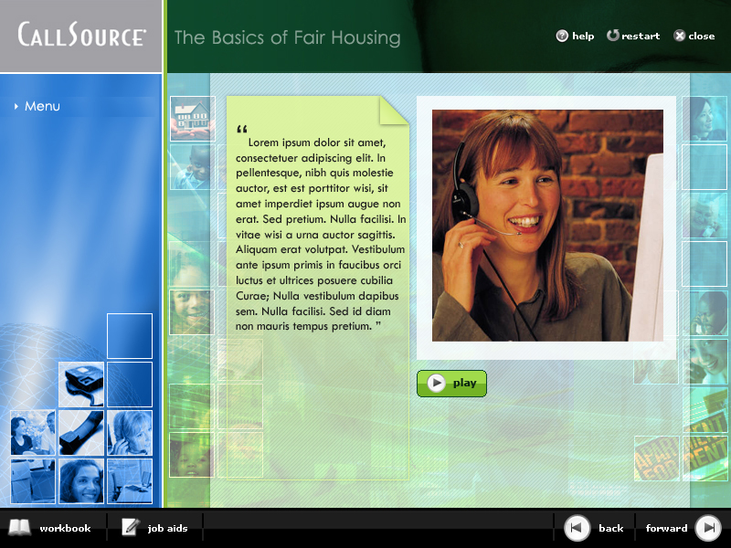 | Definition Screen  Photo, Audio, Text Screen  Photo, Audio, Text, Quiz Screen
 | Video Style(s)  a. Interface  b. Navigation buttons  c. Page layout  d. Display box for video  e. Video dimensions | 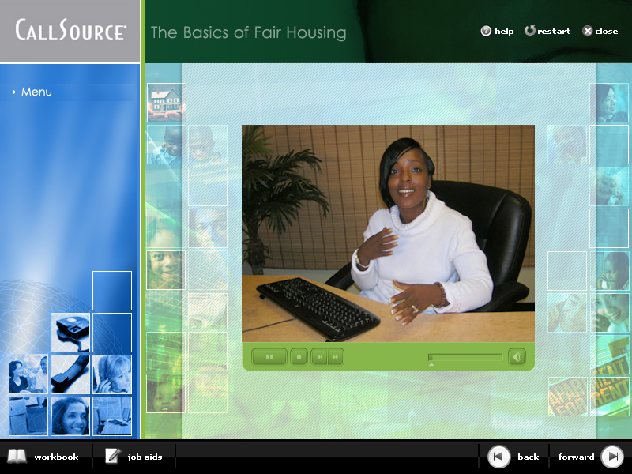 | Video Screen
 | Interactive Exercises  - Quiz Screen  - Rank Order  - History  - Knowledge Mapping  -- Case Study | a. Interface  b. Navigation buttons  c. Page layout  d. Fonts  e. Image style(s) – photos, cartoons, illustration  f. Text display  g. Audio – sound, voice overs  a. Description  b. Mechanics | [link to sample mock-up]  Under construction
 | Other Components | a. Resolution Targets : 800x600 px  c. Naming Convention  d. Terminology  e. Time out  f. Frame Rate  g. Animated Logo

